Merchant Acquiring System
Owner (Group): Merchant Documentation Management
ID: | 258 | Story Name: | New Affiliation Request Creation – MERCHANT DOCUMENTATION MANAGEMENT – User |  | Release/Iteration: | 1
Assigned To:
Description: Manage Insufficient Requirements, Prints Welcome Letter.
User Story Steps:
- Log in to the system
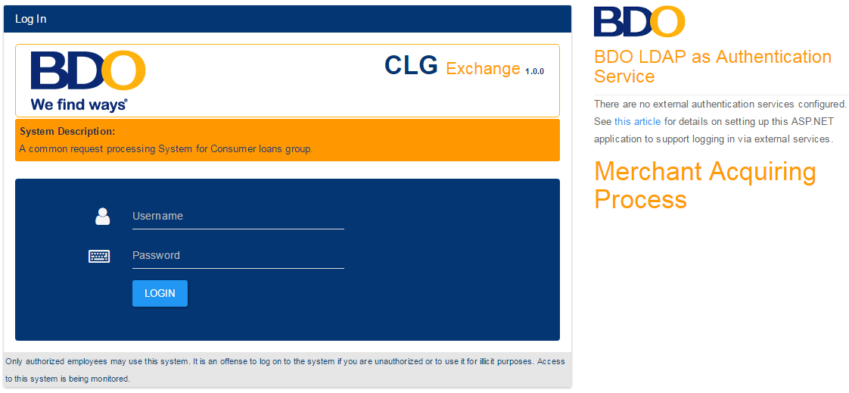
Username and Password validation follows the BDO user authentication standard.

- System displays the dashboard for MDM User with requests that are tagged as “For Terminal Installation”.
All Request that has required documents that are not yet submitted(e.g. If the submitted checkbox on the “Document List” is not ticked) shall be displayed on the dashboard.
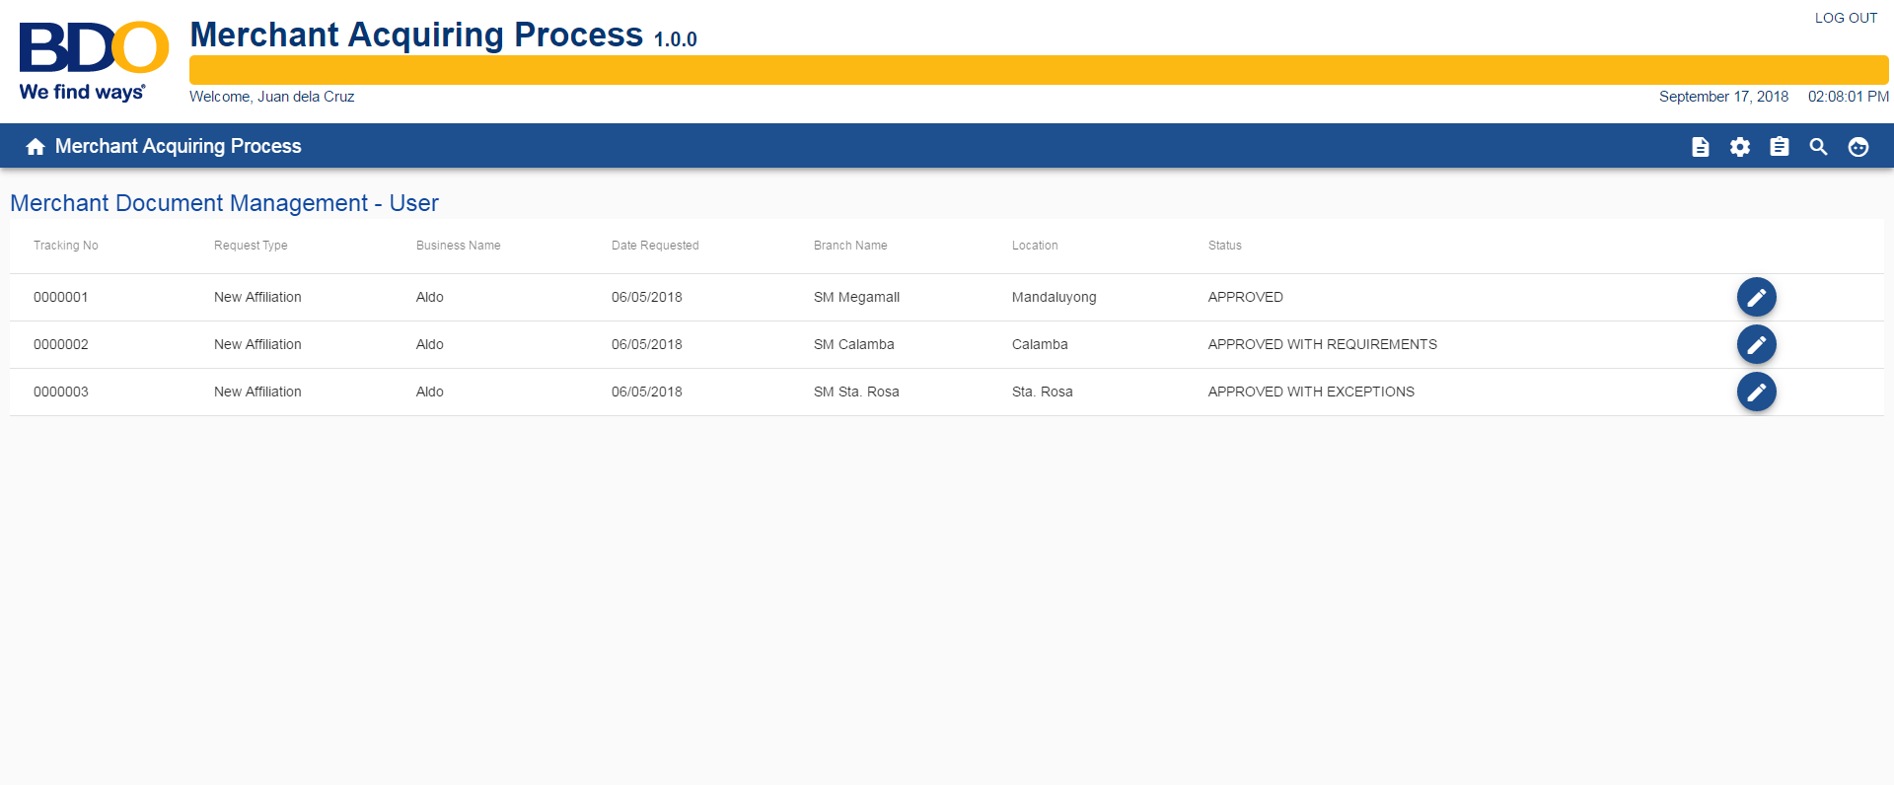

- User selects and click the request on the dashboard.
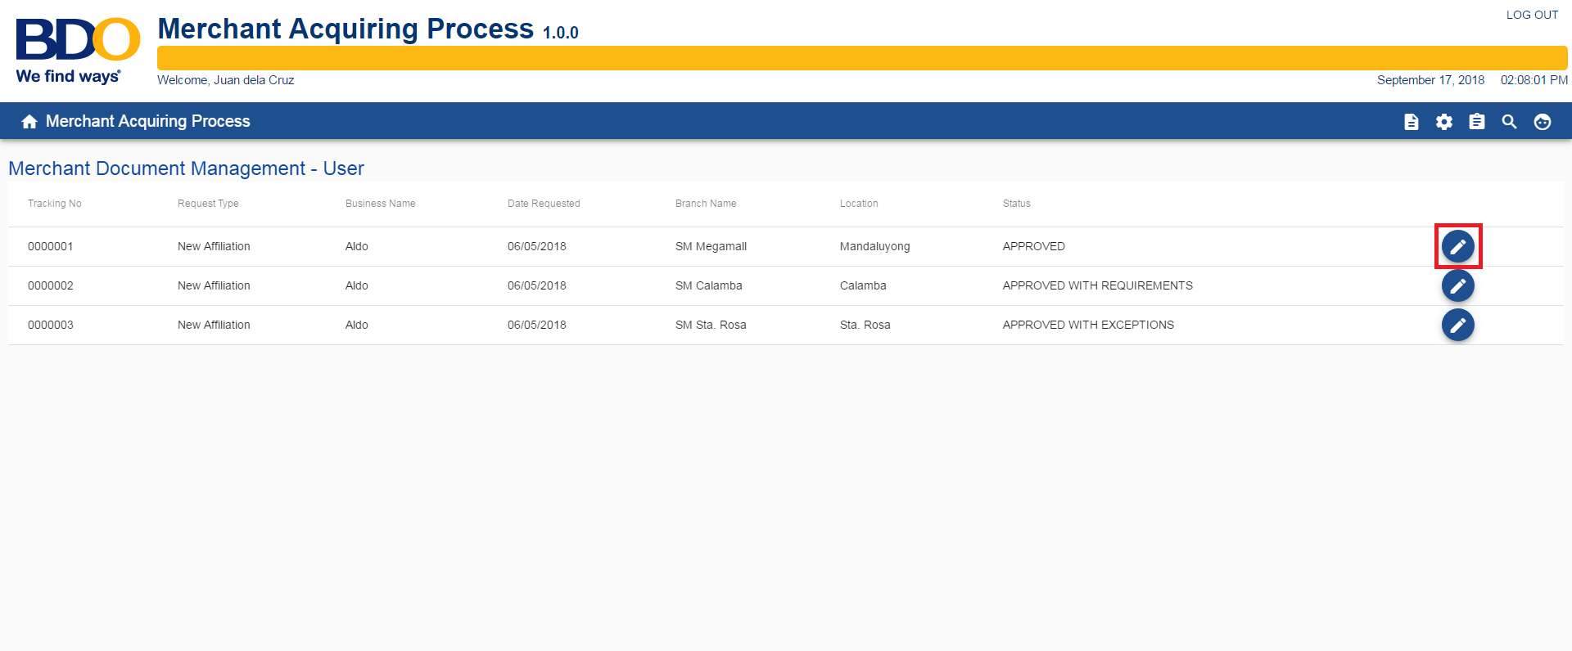

- System displays the details of the request.
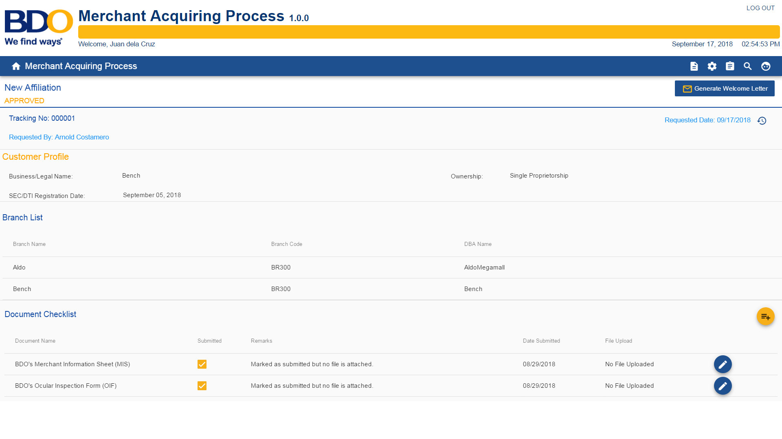
- User has an option to tick a document if they received a hard copy.

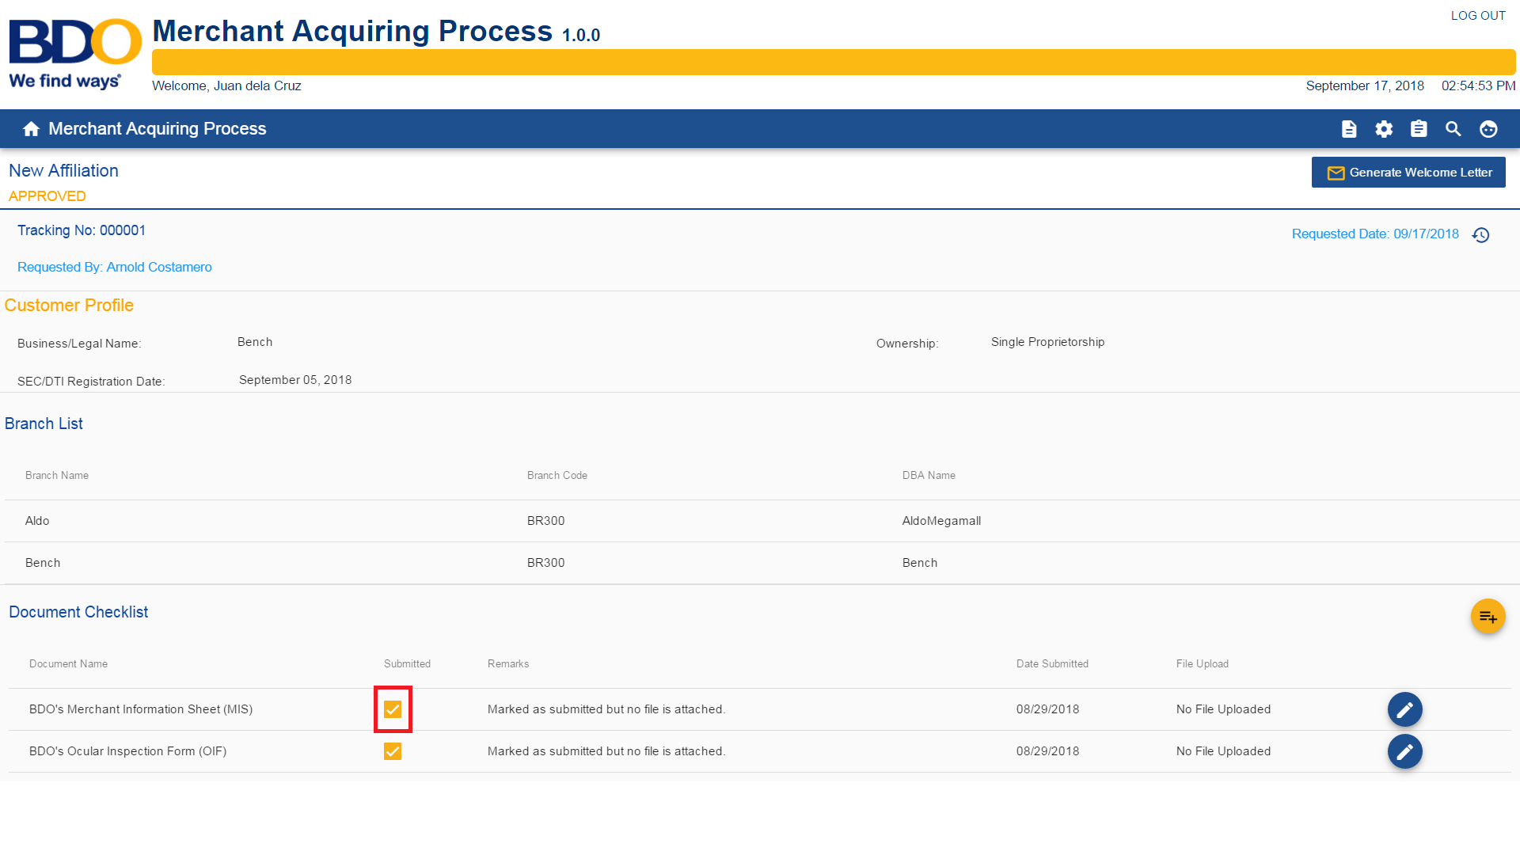

- User has an option to add a Document Checklist per request level.
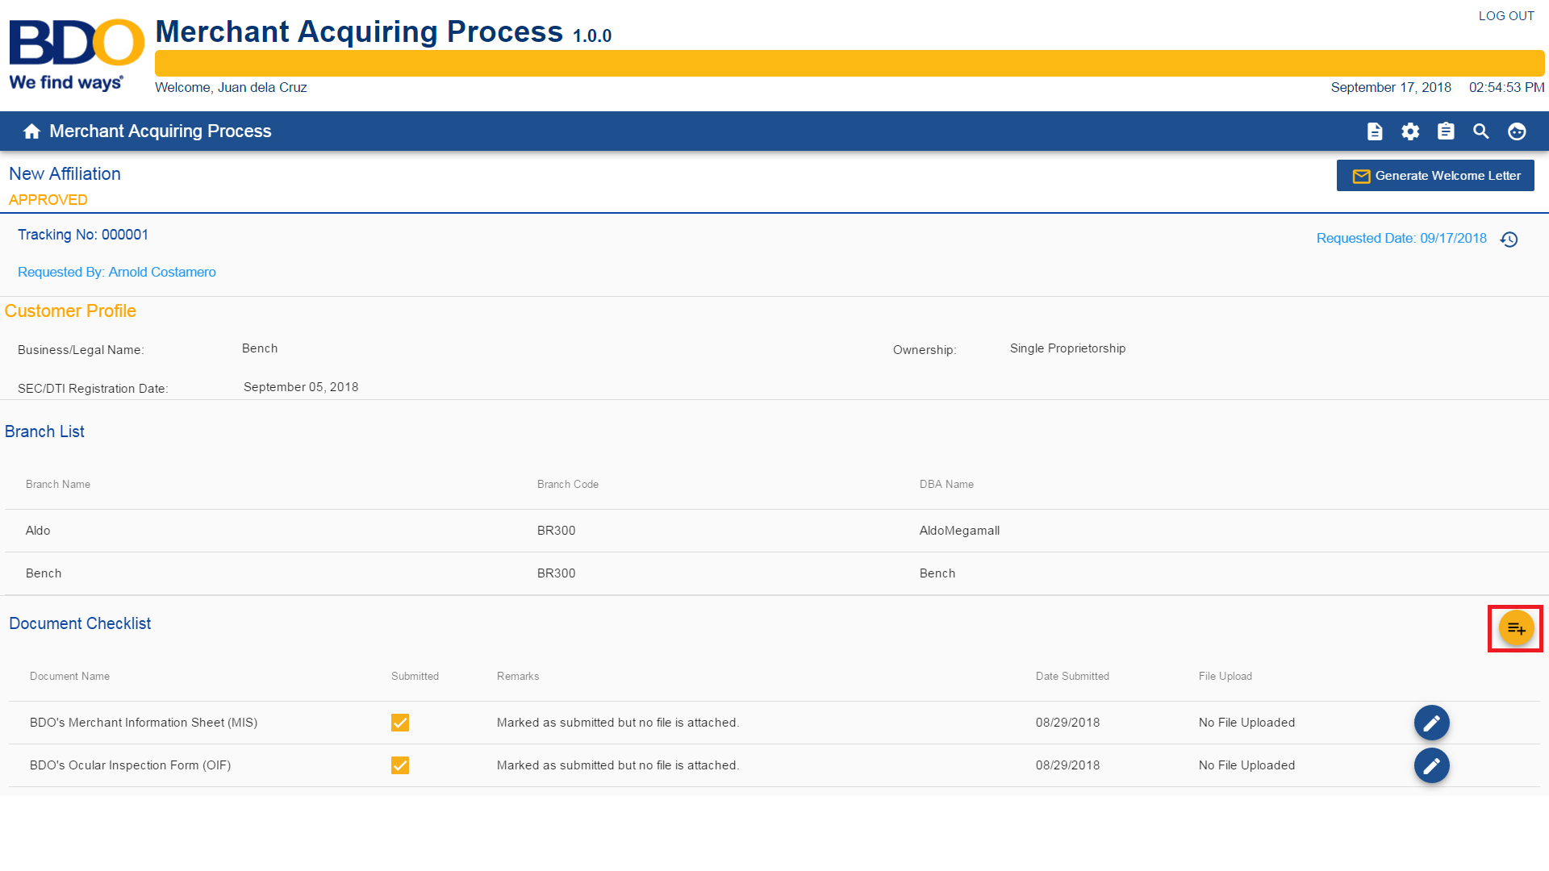
Note: By clicking the button, the document list table will be replaced by a Document Checklist Form

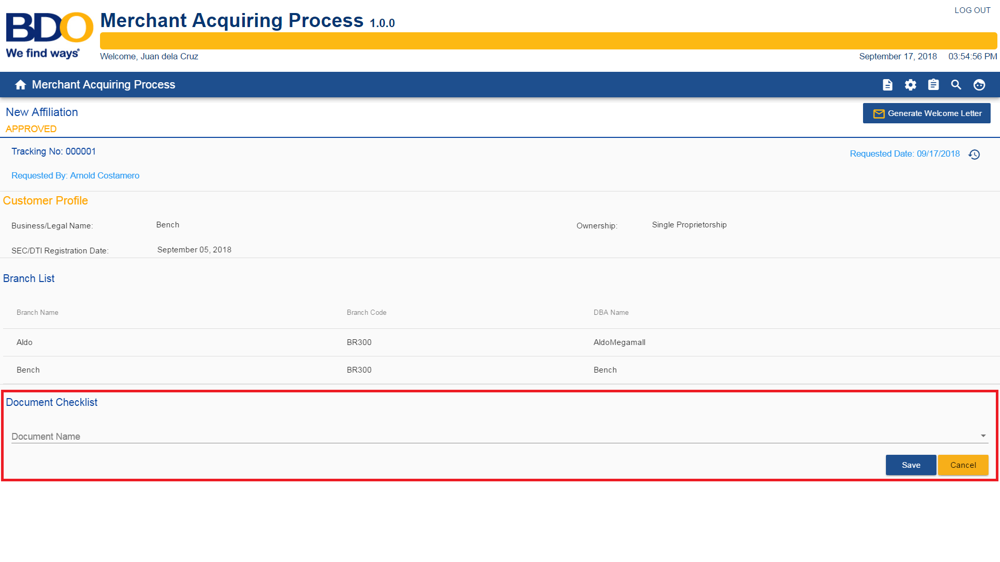
Refer to the attachment for the validation of the fields. [User Story 12 – MDM User – Field Criteria – New Affiliation Request.xls]

- User has an option to Generate Welcome Letter for all the branches included in the request.
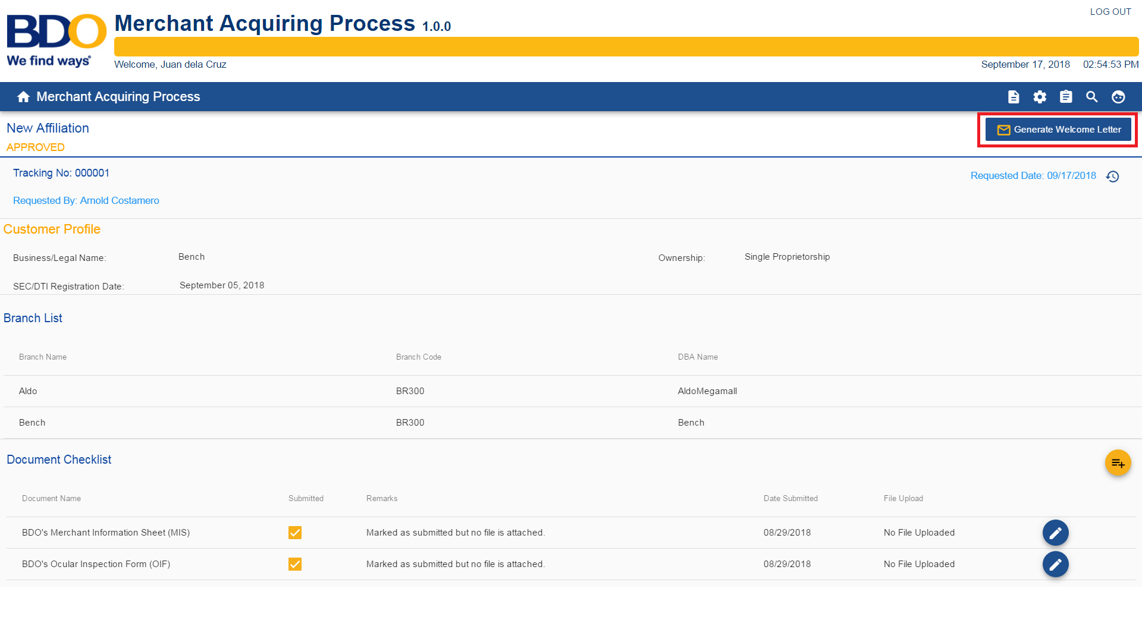
- If Ao has completed the submission of the requirements, user has click the completed button.
<Put screen shots here>
- User logs out from the system by clicking the logout button on the upper-right corner of the screen.
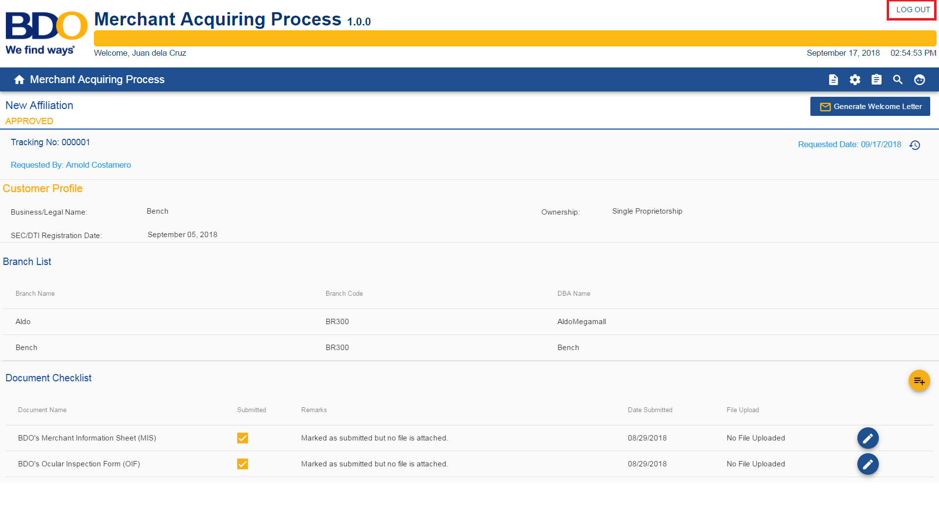

Acceptance Criteria:
Estimates: x days |  |  |  | Actual: x days
Arnold Costamero
Analyst |  |  |  | Owner

